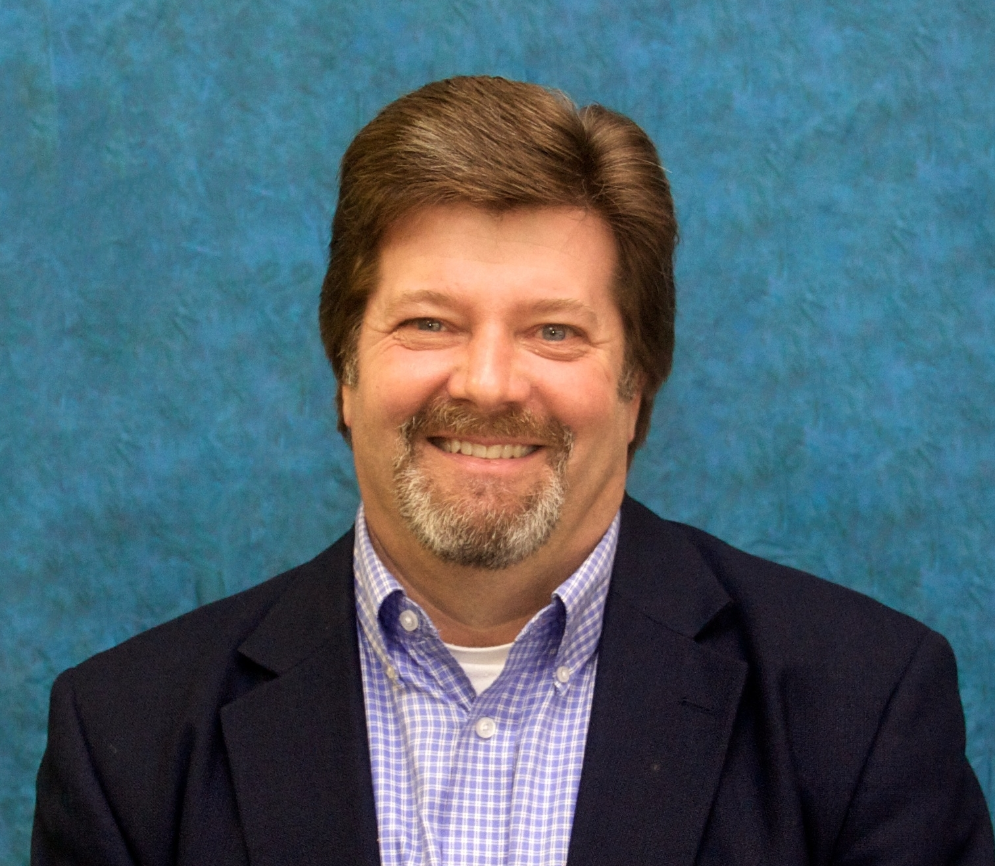
Dr. Paul Frick is the Roy Crumpler Memorial Chair and tenured full professor in the Department of Psychology at the Louisiana State University. He has published over 235 peer-reviewed publications, over 55 chapters in editor books, and he is the author of 7 additional books and test manuals. A continuing line of research focuses on understanding the different pathways through which youth develop serious antisocial behavior and aggression and the implications of this research for assessment, treatment, and public policy. His work has been funded by the National Institute of Mental Health, Office of Juvenile Justice and Delinquency Prevention, National Institute of Justice, National Health Medical Research Council of the Australian Government, W.T. Grant Foundation, and the John T. and Catherine D. MacArthur Foundation.

Dr. Frick has received a number of awards for his research. He was awarded the 2015 Robert D. Hare Lifetime Achievement Award from the Society for the Scientific Study of Psychopathy. In 2020 he received the award for Contributions in Psychological Science from the Louisiana Psychological Association. In 2021, he was awarded the Bob Smith, Excellence in Psychological Assessment Award from the Society for Clinical Child and Adolescent Psychology (SCCAP), Division 53 of the American Psychological Association. Dr. Frick was the editor of the Journal of Clinical Child and Adolescent Psychology (2007-2011), the official journal of Division 53. He is currently the editor of Research on Child and Adolescent Psychopathology, the official journal of the International Society for Research on Child and Adolescent Psychopathology. Dr. Frick was a member of the American Psychiatric Association’s DSM-5 Workgroup for ADHD and the Disruptive Behavior Disorders (2007-2012) and was the Section Editor (2018-2021) of the Disruptive, Impulse-Control, and Conduct Disorders chapter for the DSM-5-TR.

